The pan-European network with global capabilities
Transforming the way researchers collaborate
connect • communicate • collaborate

The GÉANT network delivers real value and benefit to society by enabling research communities across Europe, and the rest of the world, to transform the way they collaborate on ground-breaking research.
Bioinformatics
The European Bioinformatics Institute (EBI), part of the European Molecular Biology Laboratory (EMBL) collaborates with hundreds of partners around the world to manage terabytes of information from thousands of life sciences projects and make this rapidly increasing data available to all.
To share information EMBL-EBI works closely with UK NREN JANET and GÉANT who provide a robust and high-speed network architecture that currently transmits over 80 terabytes of data per month to users around the world.
“The EBI would not exist without GÉANT, because our primary goal is to collect and distribute biological data… Without GÉANT we could not do that.”
Professor Janet Thornton, Director of EMBL-EBI and Coordinator of ELIXIR
Neuroscience
The DECIDE project enables the faster diagnosis of diseases such as Alzheimer’s through a simple to use, grid-based system that provides the processing power to analyse increasing volumes of patient data.
DECIDE’s unique infrastructure relies on the GÉANT network to connect powerful computing resources and international databases to enable clinicians to quickly upload, analyse and compare medical imaging data, enabling faster, more informed diagnoses.
“Data sharing and processing on the scale needed by the DECIDE project would be impossible without the high-speed, seamless and reliable GÉANT network operating across Europe.”
Laura Leone, DECIDE Project Coordinator

Green ICT
The GreenStar Network project was created to prove the viability of using green energy sources, initially in research networking, that can reduce ICT’s carbon footprint. GSN uses GÉANT’s high-speed Bandwidth on Demand links to create an interactive green network, which includes advanced middleware to maximise how renewable-powered resources are used.
“None of this would be possible without flexible, high performance international research networks such as GÉANT that provide real time monitoring and control to deliver a virtualised green architecture.”
Mohamed Cheriet, Project Instigator, GreenStar Network
The Pan-European Research and Education Network Network Topology Map, March 2012
Backbone topology as at March 2012.
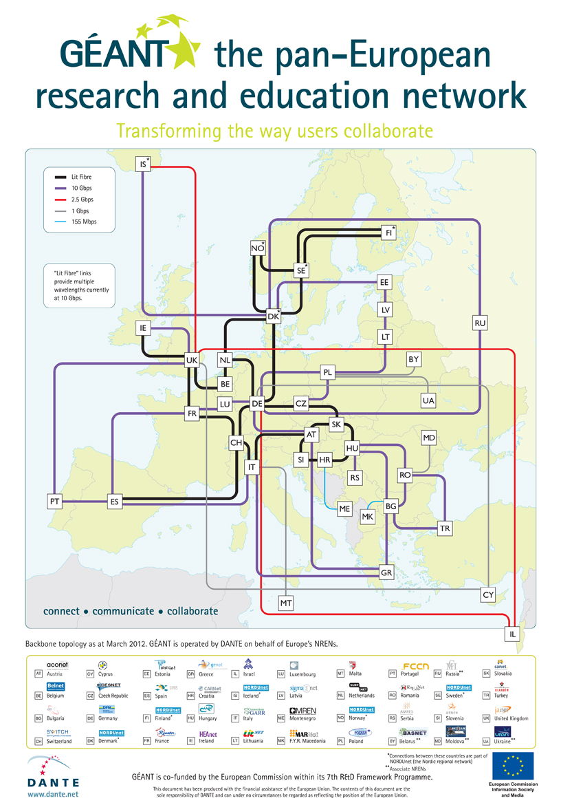
At the Heart of Global Research Networking
Global Connectivity Map, March 2012

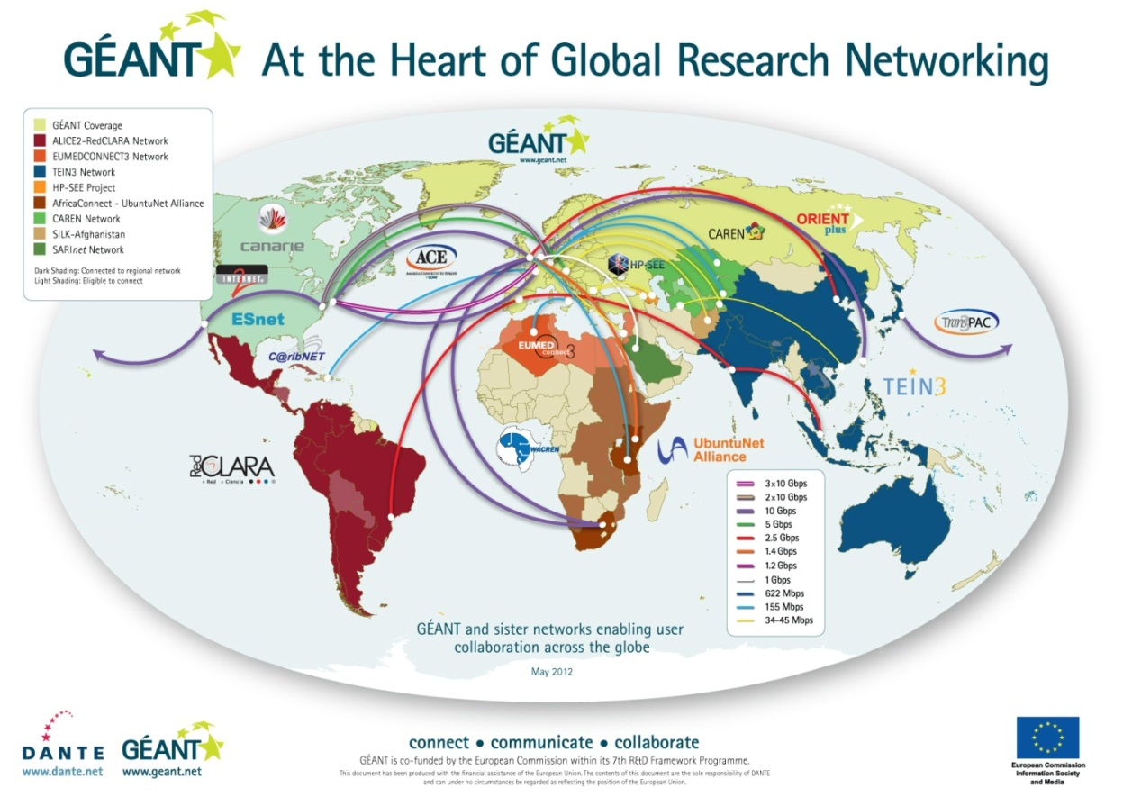

Global connectivity
In addition to its pan-European reach, GÉANT has extensive links to networks in other world regions including North America (via Internet2, ESnet, NLR, NISN and CANARIE), Latin America, North Africa and the Middle East, South Africa and Kenya, the South Caucasus, Central Asia and the Asia-Pacific Region – reaching over 50 NRENs and a further 45 million users outside of Europe, putting GÉANT at the heart of global research networking. Work is also on-going to connect to the Caribbean and to improve links to and within Southern and Eastern Africa, providing researchers worldwide with a gateway to European counterparts.

Innovative topology for advanced services
GÉANT was the first production ‘hybrid’ network deployed on an international scale, using an innovative combination of routed IP and switched infrastructure to open up new service possibilities. GÉANT offers IP and Point-to-Point connectivity services, as well as dedicated Wavelengths and Bandwidth on Demand – the world’s first and only multi-domain service for automatic bandwidth provisioning.
What is GÉANT?
GÉANT is the pan-European research and education network that interconnects Europe’s National Research and Education Networks (NRENs).
Together we connect over 40 million researchers and students across Europe, facilitating collaborative research in a diverse range of disciplines, including high-energy physics, radio astronomy, bio-medicine, climate change, earth observation and arts & culture.
GÉANT is part-funded by, and works in close cooperation with the European Commission (EC). GÉANT is fundamental to realising the EU’s vision for the European Research Area (ERA), and is a key part of the Digital Agenda for Europe, a flagship initiative driving Europe 2020.
What sets GÉANT apart from other networks?
- The robustness that large research projects rely on – outstanding service availability and service quality. Over 1,000 Terabytes of data are transferred every day via the GÉANT IP backbone.
- The flexibility that means services and infrastructure can be tailored to individual user requirements.
- The capacity, combined with extreme robustness and high availability, which sets GÉANT apart.
- Key routes on GÉANT already run at 40 Gbps, with planned upgrades to 100 Gbps scheduled for 2012 to ensure the network remains ahead of user demand for bandwidth.
- The effective and efficient operations users come to expect, as delivered by a dedicated Network Operations Centre. 99% of cases are reported within 15 minutes of the outage being detected.
- All the services needed for seamless networking experience: IP and dedicated circuits test-beds and virtualised resources, authentication and roaming, monitoring and troubleshooting, advisory and support services.
By excelling in the key areas of robustness, flexibility, capacity and operations, GÉANT is enabling the research and education communities to focus on what they do best – collaborating on vital projects that push back the boundaries of knowledge.
Further Information
Go online to learn more about GÉANT and keep up to date with the latest developments
www.geant.net
www.twitter.com/GEANTnews
www.facebook.com/GEANTnetwork
www.youtube.com/GEANTtv
GÉANT is operated by DANTE on behalf of Europe’s NRENs.
Also available in this series:
Enabling global user communities
Delivering user services across borders
GÉANT is managed and operated on behalf of Europe’s NRENs, offering outstanding service availability and service quality.

